**Appendices 2. Uncertainty module User Manual**

**Table of Contents**

Acknowledgements 1

Disclaimer 2

Contacts for User Support 2

1．Introduction 2

1.1 About the Uncertainty module 3

2．Usage Guidelines 4

2.1 Model introduction 4

2.2 Detailed operation 5

2.2.1 Deterministic sensitivity analysis 5

2.2.2 Probabilistic sensitivity analysis 6

2.2.3 Sensitivity analysis output 7

3.Further Investigations 9

# Acknowledgements

This manual was developed by Baiyang Gu in collaboration with Liangru Zhou. Uncertainty module was developed by Liangru Zhou, Zhiwei Rong, Bingjie Liu, Baiyang Gu, Yue Li, Guoxiang Liu and Xin Zhang. This version was not related to the WHO. We thank Peiyan Ju,Yi Li and Yue Huo for providing feedback on the pilot version of Uncertainty module. We also thank Mark Jit,Marc Brisson,Allison Portnoy and Raymond Hutubessy for developing PRIME on which we can conduct our research.

# Disclaimer

The named authors [or editors as appropriate] alone are responsible for the views expressed in this publication.The results calculated with this tool depend on the assumptions and values entered by its users.Users of the tool alone are responsible for the results they generate with it.

This disclaimer applies to all information within this tool,including but not limited to example workbooks,worksheets,user manuals,training, and resources.We recommends that you seek independent advice before relying upon or acting on any information in this tool.We accepts no responsibility for any loss,damage,cost or expense (whether direct or indirect) incurred by you as a result of any error,omission or misrepresentation in any information in this tool.

# Contacts for User Support

Further information and advice on using Uncertainty module can be obtained by contacting zlr1220@126.com.

# 1．Introduction

Cervical cancer is an important cause of new cases and deaths among women worldwide.In the global strategy to eliminate cervical cancer adopted by the World Health Assembly in 2020,it is proposed that 90% of girls should be vaccinated against HPV before the age of 15 by 2030,which means that HPV vaccines in low and middle-income countries need urgent attention in the next decade.Immunization programme activities.Estimates of the possible health and economic impacts of HPV vaccination will provide important evidence to support the introduction of the vaccine into national immunization programme.

Scientists at the London School of Hygiene and Tropical Medicine and Laval University in Quebec,together with the World Health Organization in Geneva,have developed the Microsoft Excel-based Papillomavirus Rapid Interface for Modelling and Economics (PRIME) to assess the full range of vaccinations of adolescent girls before first sexual activity The cost-effectiveness of the HPV vaccine provides non-modeling users with a plan for rapid economic evaluation of the entire HPV vaccination process, which has been widely used around the world. However,PRIME only provides cost-effectiveness results and does not provide an uncertainty analysis module.

We have extended PRIME to include modules that can perform uncertainty analysis of model parameters to reduce bias in economic evaluation results.This guide describes the expanded uncertainty analysis module of the PRIME model and describes how to use it.

## About the **Uncertainty module**

The uncertainty analysis module is extended on the basis of the PRIME model,and provides users with tools to carry out uncertainty analysis after baseline economic evaluation.This module mainly includes two uncertainty analysis methods:

* Deterministic sensitivity analysis(DSA):Analyze whether the results of the economic evaluation are consistent with the baseline results when changing individual parameters.
* Probabilistic sensitivity analysis(PSA):Evaluate the robustness of economic evaluation results after multiple parameters follow a certain distribution and change simultaneously.

The uncertainty analysis module is designed to help users who need uncertainty analysis after economic evaluation,so as to consider whether the results of economic evaluation have an impact on decision-making in other possible situations.DSA is carried out based on the changes of a single input parameter.PSA evaluates the impact of the changes of multiple parameters to verify the robustness of the evaluation results and provide a basis for decision-making.

# 2．Usage Guidelines

## 2.1 Model introduction

Uncertainty module is based on a new module created by Microsoft EXCEL on the PRIME model, including 3 sheets：

* DSA——Select the default variation range of each parameter to obtain the ICER value after each parameter is changed respectively.Users can customize the range of parameters.
* PSA——Select the model parameters to change randomly to ensure that the parameters can change randomly.Using Monte Carlo simulation,select the default number of iterations (1,000 times).In addition,you can also customize the number of input iterations to obtain the probability distribution of ICER values.
* Sensitivity analysis output——The results of the analysis are presented in Tornado charts and Cost-Effectiveness Acceptability Curve( CEAC) format.

These transformations between the sheets s use the sheet navigation tabs in the figure below (see Fig. 2).

**Figure 2. Sheet navigation tabs**



## 2.2 Detailed operation

### 2.2.1 Deterministic sensitivity analysis

* Deterministic sensitivity analysis was operated in the “DSA” sheet.The table is automatically populated with the default variation range,variation value and baseline ICER value for each parameter. Please make sure that the Model Type of the “PSA” sheet is “Deterministic” before performing deterministic sensitivity analysis.

**Tabel s10. Explanation of input data fields**

|  |  |
| --- | --- |
| **Field label** | **Explanation** |
| Parameter | Parameters of analysis |
| Value | Parameter baseline values |
| Decrease in baseline value | Parameter range (decrease) |
| lower bound | Parameter value after parameter change (low value) |
| Increase in baseline value | Range ameter range (increase) |
| upper bound | Dynamic parameter value after parameter change (high value).Among them, the maximum value of the three parameters of Vaccine efficacy vs HPV 16/18、Proportion of cervical cancer cases that are due to HPV 16/18 is 100%. |
| ICER (lower) | The ICER value after the parameter change (low value) |
| ICER (upper) | The ICER value after the parameter change (high value) |
| Absolute Value | Absolute value of the ICER difference after the parameter change |

* To use a custom parameter variation range,enter custom values in the “Decrease in baseline value” and “Increase in baseline value” gray fields to override the default values,and click the “RUN DSA” button to generate the result (Fig. 3).

**Figure 3. DSA input chart example**

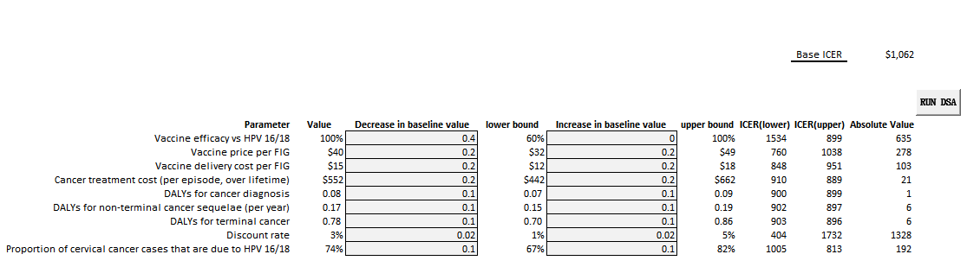

* Click the “DSA” button to run DSA and automatically generate a Tornado chart.The results are presented in the “Sensitivity analysis output” sheet.

**Figure 4. DSA results run chart example**

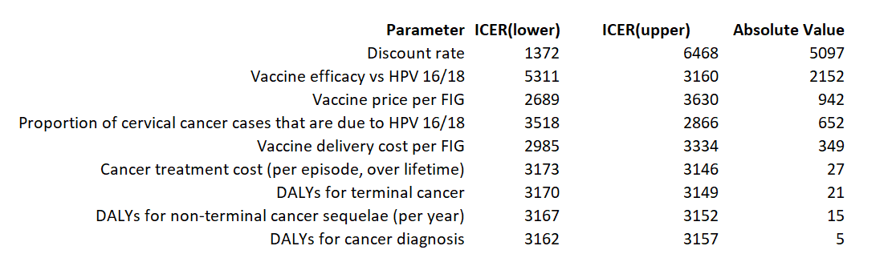

### 2.2.2 Probabilistic sensitivity analysis

* PSA is performed in the “PSA” sheet.In “Model Type” select the option “Stochastic” for random variation of model parameters (Fig. 5).Click “PSA” to run, and the results are displayed in the “Sensitivity analysis output” sheet.

**Figure 5. PSA input chart example**

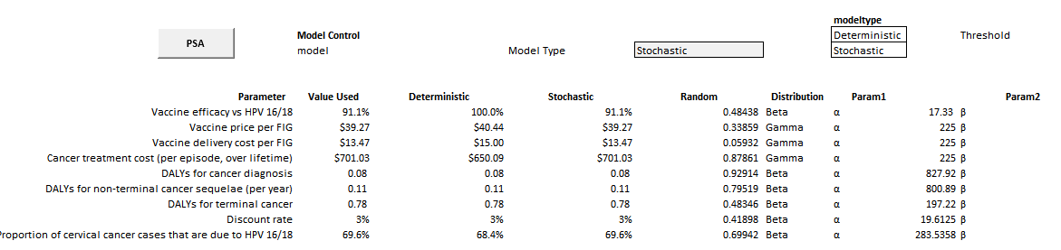

* The default number of iterations for Monte Carlo simulation is 1,000.If other simulation times less than 1,000 are used,enter a custom number of iterations in the “numruns” pink area (Fig. 6).

**Figure 6. Example of a Monte Carlo simulation run chart**

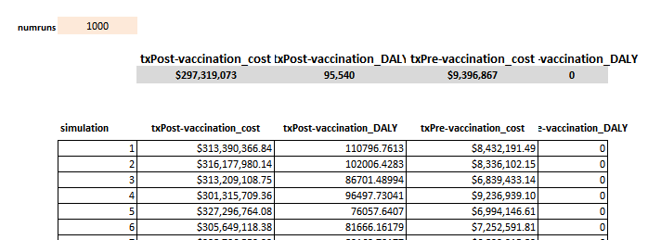

### 2.2.3 Sensitivity analysis output

The resulting output module includes three graphs.The first graph shows the results of the DSA,and the second and third graphs show the results of the PSA.

#### 2.2.3.1 Results of the DSA

The results of the DSA are output in the form of Tornado charts.The horizontal axis represents the change result of ICER value,the vertical axis represents the analyzed parameter,the middle line represents the baseline result,and the bar length represents the range of parameter change in the analysis.The ends of the bars are the upper and lower bounds of the range for each parameter.Starting from the top of the graph, the bars are arranged in order from longest to shortest,that is,the parameter values are arranged from large to small based on the range of changes in the ICER value.The Tornado chart shows the degree of influence of each parameter on the economic evaluation results and the robustness of the economic evaluation results when each parameter changes (Fig. 7).

**Figure 7. Tornado chart**

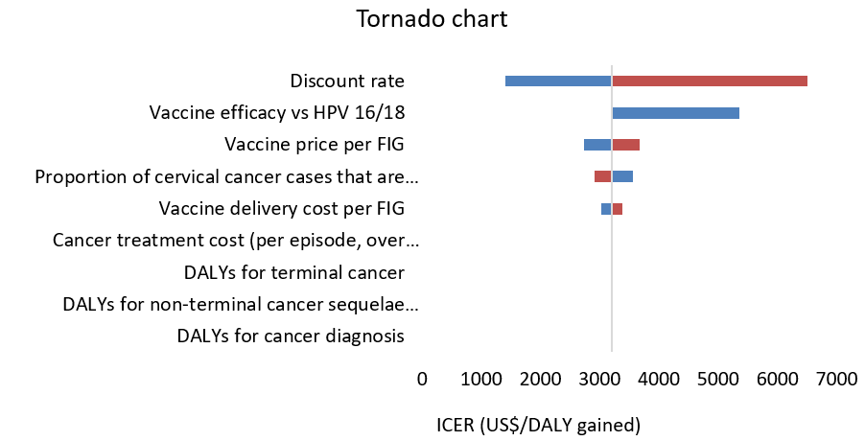

#### 2.2.3.2 Results of the PSA

The PSA produced a incremental effects scatter plot and a CEAC.The points identified by incremental cost and incremental effect in Fig.8 are plotted in the four quadrants represented by the X and Y axes,respectively,and the slope of the line connecting the origin to any cost-effect combination is the ICER result.In the process of generating the incremental effects scatter plot,you can set the axes to adjust the image by entering numerical values in “X” “Y” according to the threshold.

The threshold in the scatter plot provides evidence of the robustness of the cost-effectiveness analysis results,such as at a specific threshold,all scatter points are averaged below the threshold line,indicating that the economic evaluation results are robust.

**Figure 8. Incremental effects scatter plot**

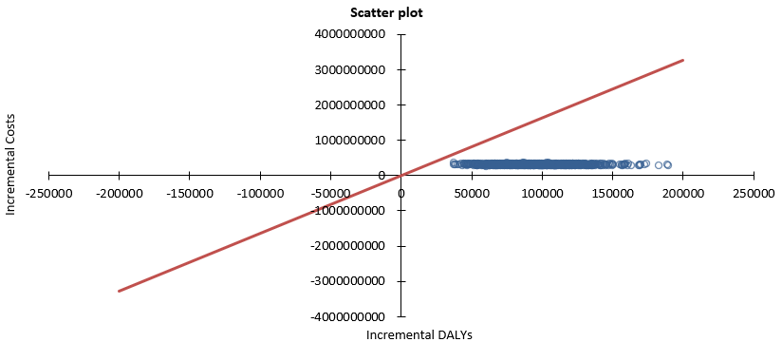

Fig. 9 is the CEAC, in the case of using the net benefit measure, the result of PSA can be displayed as CEAC.The abscissa is the cost-effectiveness threshold,and the ordinate is the probability of cost-effectivenes.The CEAC shows the probability that an intervention is cost-effective at each upper proportion (or WTP threshold), visualizing the results of PSA.

**Figure 9. CEAC**

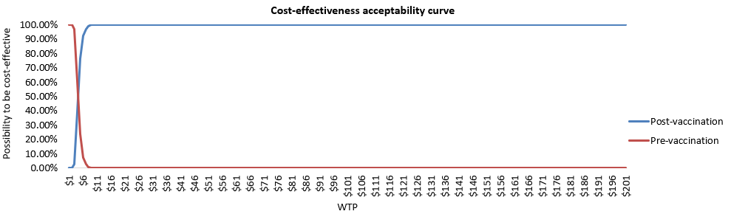

# 3.Further Investigations

Further information about Uncertainty module can be found

on the tool’s website at <https://github.com/PRIME-Uncertainty/PRIME-Tool-Uncertainty-Analysis>.